R.M.S. Europa
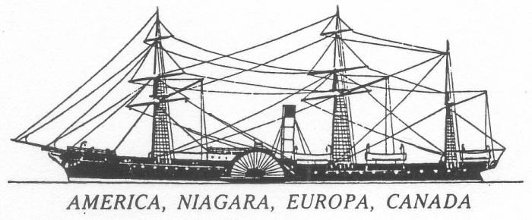
Europa
1848 - 1867 in Cunard service
Launched September 1847
Builder: Robert Steele & Co., Greenock (Glasgow), Scotland
1,834 gross tons
Dimensions: 76.5m x 11.6m
One funnel
Three masts
Wood hull
Propulsion: Paddle (sidewheel)
Two side lever jet condensing reciprocating steam engines,
built by Robert Napier, Glasgow
670 horsepower [500 kilowatts]
Normal working steam pressure: 18 pounds per square inch [120 kPa]
Four boilers, flue (fire-tube) type
Sixteen furnaces consuming 60 tons of coal per day
Bunker capacity: 450 tons (7.5 days at normal speed)
Service speed: 10 knots [18.5 km/h]
Fuel consumption: 7.3 kilometres per ton of coal
Accommodation: 140 First Class passengers
Crew: 90
Cargo capacity: 450 tons
In 1847 it became apparent to the government that the postal facilities had become too limited for the demands arising from the rapidly extending commercial relations between Britain and America, and they wisely determined to double the Atlantic mail service. A new contract was entered into with the Cunard Company whereby a vessel of not less than 400 horsepower, capable of carrying the highest calibre guns, should leave Liverpool every Saturday for New York and Boston alternately. To accomplish this new agreement four new ships were built: America, Niagara, Europa and Canada.

Europa was launched in September 1847 and departed Liverpool on its maiden voyage on 17 July 1848 to Boston and Halifax; the final destination on subsequent voyages varied between New York and Boston. In June 1849 it collided with the emigrant ship Charles Bartlett which sank with the loss of 135 lives. The mizzen mast was removed in 1853 and in 1854 it became a Crimean War transport. In August 1858 it collided with another Cunard vessel, Arabia, off Cape Race and both were damaged. In February 1866 it made its last voyage from Liverpool to Boston and was sold the following year.

